OUR BUSINESS
Overview:
Driven by innovation and heavy investment in Research & Development, our company introduces Wires Of tomorrow. Safety, security and durability are our prime concerns. That's why our wires pass through the toughest of tests before it reaches you. And it will redefine the way you live. Our company stepped into the manufacturing of Wire & Cable in 2008.
Our Company is an established player in the Wire & Cable Industry among the largest Wire & Cable manufactures in India having more than five years of rich experience of the International Industry. Over the period of last five years we have established our reputation and reliability in various markets in India as well as abroad. Our Company, based on its experience and standard, confirms to major specifications and customer requirements and accordingly manufacture the products which provide us the value addition and technical edge.
Earlier to 2010 our company used to purchase Copper and Aluminium Wires from the outsider to manufacture its final products, however in year 2010 our Company made the backwards integration installing the Copper and Aluminium wire drawing facility which, in turn, added value to the organization in terms economies of scale and production of Copper and Aluminium wires in our accordance.
About Us:
Our company was incorporated on June 12, 2008 to manufacture and trade cables. Over the years we have been expanding our product range and have added variety of cables in our product range. We moved up the value chain by identifying new opportunities and diversifying the product portfolio. The registered office of the company is situated at, 7A/39, WEA Channa Market, Karol Bagh, New Delhi, Delhi-110005, India and manufacturing unit at E-424, RIICO Industrial Area, Chopanki, Bhiwadi, Tehsil-Tijara, District-Alwar, Rajasthan.
Product Portfolio:
We are one of the leading manufacturers of Wires & Cables which include Armoured Cable, Unarmoured Cable, Flexible & House Wires, Submersible Cable, Control & Instrumentation Cable. These are manufactured using quality material which is checked at every stage of production by our highly experienced quality controllers.
OUR PRODUCTS
Armoured Cable
Armoured cables are generally used for underground wiring. Armoured cables are power cables which comprise of two or more electric conductors which are enveloped in a protective sheath. The cable derives its name from its protective nature and allows better electric transmission with lesser risks involved. The significance of armoured cables lies in its construction. Each and every component plays a significant role in energy transmission. The conducting wires which are mostly made of copper offer superior conductivity. The cross-linked polyethylene insulation enveloped in wires allows better energy transmission by preventing external alterations.

Armoured cables are more flexible than their counter-parts and this makes them the first choice for industrial purposes. The installation bends and twists involved in installation do not hamper its external shape and energy transmission. The mechanism involved in these cables allows better flexibility thus, making it durable for large electric transmission. The chromium content in the steel armour protects the cable from external harsh environment when exposed to it. The heat-resistant ability of armoured cables should be attributed towards the PVC bedding and the external layer of steel armour. The external protection in conductors allows better transmission of energy under high pressure. | 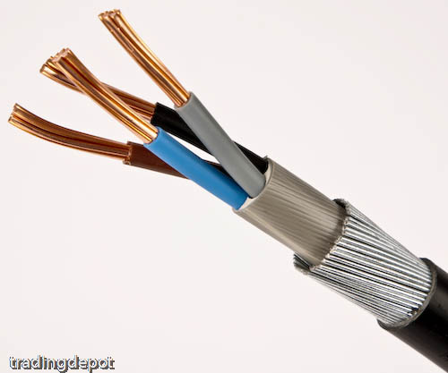
Unarmoured Cable
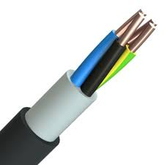 | Unarmoured electrical cable has no protective flexible steel covering, its covering is made of plastic.

Flexible & House Wires

Flexible cables, or 'continuous-flex' cables, are cables specially designed to cope with the tight bending radii and physical stress associated with moving applications, such as inside cable carriers. Due to increasing demands within the field of automation technology in the 1980s, such as increasing loads, moving cables guided inside cable carriers often failed, although the cable carriers themselves did not. In extreme cases, failures caused by "corkscrews" and core ruptures brought entire production lines to a standstill, at high cost. As a result, specialist, highly flexible cables were developed with unique characteristics to differentiate them from standard designs. | 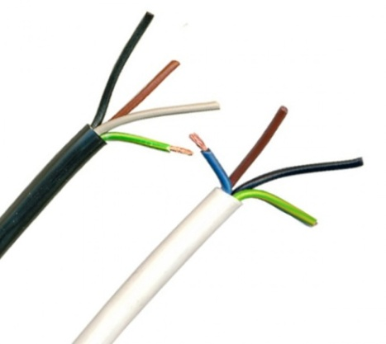
These are sometimes called “chain-suitable,” “high-flex,” or “continuous flex” cables. A higher level of flexibility means the service life of a cable inside a cable carrier can be greatly extended .A normal cable typically manages 50,000 cycles, but a dynamic cable can complete between one and three million cycles. Flexible cables can be divided into two types: those with conductors stranded in layers inside the cable, and those that have bundled or braided conductors. Flexible cables manufactured by us include:

- Single Core PVC Insulated Copper Conductor (Unsheathed) Flexible Industrial cables, 1100 Voltage Grade (Colour: Red/Yellow/Blue/Black/Green)

Nominal Cross Sectional area of conductor  sq. mm | Number/Nom. Dia of cond. Strands*  mm | Thickness of Insulation (Nom)  mm | Approx. overall  Diameter  mm | Current carrying capacity 2 cables single phase | Max.  conductor resistance per KM at 20⁰ C  ohms
Unenclosed clipped directly to a surface or on a cable trays
amps
10  16  25  35  50  70  95  120  150  185  240 | 80/0.4  126/0.4  196/0.4  276/0.4  396/0.4  360/0.5  475/0.5  608/0.5  750/0.5  925/0.5  1221/0.5 | 1.0  1.0  1.2  1.2  1.4  1.4  1.6  1.6  1.8  2.0  2.2 | 6.1  7.0  8.6  9.7  11.5  13.0  14.9  16.4  18.3  20.1  22.9 | 46  62  80  102  138  214  260  305  355  415  500 | 1.91  1.21  0.780  0.554  0.386  0.272  0.206  0.161  0.129  0.106  0.0801
*The number and diameter of conductor strands are for reference only. Conductor resistance as per IS: 8130 is the governing criteria.

- Multicore Round PVC Insulated Copper Conductor and PVC Sheathed Flexible Industrial cables, 1100 Voltage Grade
Nominal Cross Sectional area of conductor  Sq. mm | Number/Nom. Dia of cond. Strands*  mm | Thickness of insulation  mm | Nominal Thickness of Sheath |  |  | Approx. Overall Diameter |  |  | Current Rating AC  Amps | Voltage Drop/Amp/Meter |  | Max. Conductor Resistance per KM at 20⁰ C  ohms
 |  |  | Two Core  mm | Three Core  Mm | Four Core  mm | Two Core  mm | Three Core  mm | Four Core  mm |  | DC or Single phase AC  mV | 3 Phase AC  mV
0.5  0.75  1.0  1.5  2.5  4.0  6.0 | 16/0.20  24/0.20  32/0.20  30/0.25  50/0.25  56/0.30  84/0.30 | 0.6  0.6  0.6  0.6  0.7  0.8  0.80 | 0.9  0.9  0.9  0.9  1.0  1.0  1.1 | 0.9  0.9  0.9  0.9  1.0  1.0  1.1 | 0.9  0.9  0.9  1.0  1.0  1.0  1.2 | 6.2  6.6  6.9  7.4  8.8110.2  11.5 | 6.5  6.9  7.3  7.8  9.4  10.9  12.2 | 7.0  7.5  7.9  8.7  10.2  11.9  13.6 | 4  7  11  13  18  24  31 | 83  56  43  31  18  11  8 | 72  48  37  26  16  9.6  7 | 39.0  26.0  19.5  13.3  7.98  4.95  3.30

Submersible Cable

Submersible cables help transmit energy in submerged devices. Fully submersible, these cables with their tough robust insulation allows better energy transmission and helps avoid accidents. Primarily used to supply energy to submersible pumps, these cables can also be used to extract water from deep underground reservoirs. However, there are various kinds of submersible cables and each differs from the other in terms of performance and function. The specification of this variety of cable depends on its working environment, the electrical load and the type of external liquid it comes in contact with. Ideally, the cable used for pumping underground water should be free from harmful chemicals and provide resistance to abrasion. | 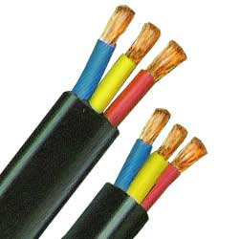
Most submersible wires are enveloped in durable rubber and plastic compounds that are flexible and provide optimum protection against the liquid it is surrounded by. Designed for excellent performance even under fully submerged condition, these cables withstand the impact of corrosive liquids and abrasion. Used in the aquarium filtration system, these cables are also used for illuminating floodlights. It’s the ideal replacement to ordinary cables in construction sites which require greater protection and resistance to water. Submersible Cables manufactured by us include:

- Three Core Flat PVC Insulated Flexible Industrial cable for Submersible use, 1100 Voltage Grade
Nominal area of conductor  Sq. mm | Insulation |  |  | Sheath Approx Overall Dimension |  | Max. conductor resistance per at 20⁰ C (Max.)  Ohm/km | Current Carrying Capacity at 40⁰ C  amps
 | Number/Size of Wire for each core  mm | Thickness (Nom.)  mm | Core dia. (Nom.)  mm | Width (Nom.0  mm | Height (Nom.)  mm
1.5  2.50  4.00  6.00  10.00  16.00  25.00  35.00 | 30/0.25  50/0.25  56/0.30  84/0.30  80/0.40  126/0.40  196/0.40  276/0.40 | 0.6  0.7  0.8  0.8  1.0  1.0  1.2  1.2 | 2.8  3.5  4.2  4.7  6.0  7.0  8.6  9.7 | 10.1  12.2  14.6  16.2  20.2  23.4  28.5  32.1 | 4.7  5.5  6.5  7.0  8.5  9.7  11.7  13.0 | 13.3  7.98  4.95  3.30  1.91  1.21  0.780  0.554 | 13  18  24  31  42  57  72  90

Control & Instrumentation Cable

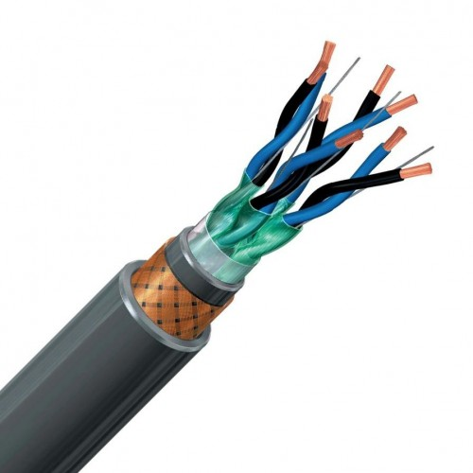 | Instrumentation cables have very diverse applications. These cables are designed for use in communication and instrumentation application in and around process industries like oil exploration, cement, paper, steel, power generation and others. Cable made to specific rigid requirements are utilized in process controls, transmission of signals, computers, control systems and monitor networks as well as in intrinsically safe systems in hazardous areas like petrochemical plants and thermal power plants.
The technological and economic development of a society is closely connected with the wire and cable industry and its suppliers. Since basically all areas of life rely on wire and the products that are manufactured from wire, and while their property potential is seemingly not yet exhausted, the wire, cable and wire processing industry is constantly faced with new challenges. In order to meeting these challenges it require machinery, tooling, accessories, ancillary equipment and services that are as efficient as possible in their utilization of energy and raw materials, and which produce as little waste as possible during startup and production

Telephone Switch Board Cables
Telephone Switch Board Cables are used for indoor Telephones, Telephone Exchanges, Satellite Telecommunication Systems, Industrial Plant Communication Systems, EPBAX Systems, Closed Circuit Security Systems, In-House Telephone wiring and various other equipments involving telephones. These Cables are generally made as per TEC Specification No. G/WIR-06/02 or as per customer specification. | 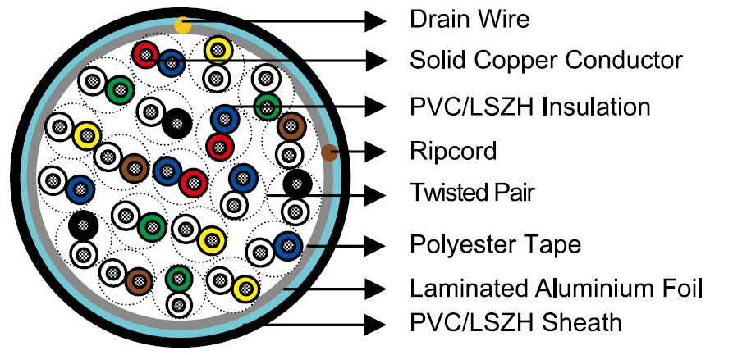

Flame Retardant-Low Smoke & Halogen Cables
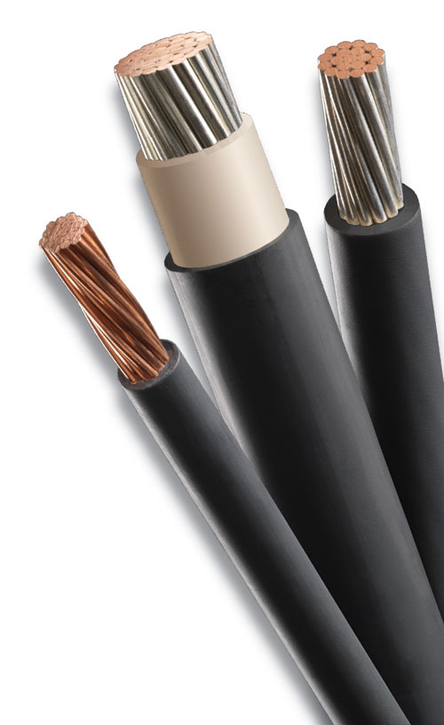 | Flame Retardant-Low Smoke & Halogen Cables are recommended for places where human concentration is high like shopping malls, buildings, offices, hospitals etc. Made up of specially formulated PVC Polymers which restrict toxic gases and smoke, and doesn’t allow fire to spread. We also manufacture Zero-Halogen Flame Retardant Cables which are manufactured using special polymeric compounds that are Halogen-free, these cables should be first choice for places like shopping malls, offices, cinema halls etc. It has a high oxygen index, thus offering superior protection against fire. Choking being the main reason of death during fire, we have designed our wires with technology that releases less toxic gas because they are halogen free. Thus reducing the chances of choking during fire. Being halogen free makes them eco friendly. As everyday, regular wires releases huge amounts of hazardous halogen gases, depleting the earth’s ozone layer.
MANUFACTURING PROCESS
The basic components for cable manufacturing are conductors (Copper/Alloy), PVC/XLPE, Dielectric Insulation, Inner Sheath, G.I. Wire, Armouring and Outer Sheath. The manufacturing of cables involves the following steps –
Drawing:
Bulk copper is formed into wire of varying diameters by drawing it through a series of dies. Wires are drawn in required sizes as per the specification by using Copper /Aluminum as well as Alloy conductor of required specification.

Annealing:
Since the drawing process causes the copper to become hard and brittle, it should be annealed. The drawn wires are then softened by heating and slow cooling. This process is called annealing. Our installed an automatic annealing system, which helps us in strengthening the drawn wires.

Stranding:
Anywhere from 20-100 (very fine copper conductor wires) are twisted into cords which will be used in making flexible wire and cable.
Layers of wires (1+6+12+18+24 etc.) are stranded together to make copper conductors. The maximum nominal cross-section area of a power cable core is 500m㎡.
The next step is stranding in which wires are grouped together in order to make the cables more flexible. In this process, smaller individual wires are twisted or bunched together to produce larger number of wires that are more flexible than solid wires of similar size. A thin coat of a specific material is coated, usually tin, on the individual wires, which provides better solder ability.
Insulation:
The copper conductors, whether they are single wire or multiple stranded wires, are covered by PVC for current insulation. Insulation is a process in which the conductors/cables are covered with material as per the requirement to provide the insulating properties required by the user according to the customer’s specification. Cables are manufactured with both thermoplastic and thermosetting insulation, insulated with PVC/PE/XLPE as required by the specification. Insulation for the cables is strictly done and applied over conductors by extrusion through the electrical process and undergoes the online H.V. Spark tests.

Core rewinding:
All insulated cores are rewound to the particular required lengths, passing through the electrical stress test i.e. spark test, which are further processed only after passing through the various physical, electrical and mechanical tests.
Cores stranding and laying process:
Three or four of these PVC insulated copper conductors are assembled into power cables. The next step is stranding, in which insulated wires called cores are grouped together, to make the cables symmetrically round. In this process, smaller individual cores are twisted or cabled together to make larger cores that are round and flexible.

Inner Sheath:
Complete cables are formed by sheathing twin-core or multiple-core PVC insulated copper conductors with PVC. Inner Sheath is a process in which the cables are coated to provide the sheathing properties as required by the user. Cables are manufactured with both thermoplastic and thermosetting extrusion. They are sheathed with PVC/PE/XLPE as required by the specification. Sheathing for the cables is strictly done and applied over insulated cable by extrusion through the electrical process and passing through the online H.V. Spark tests.

Cable Armouring:
Special purpose power cables must be surrounded with steel wires in order to increase the cable structure strength. Armouring process is conducted on inner sheathed multi core cables. Galvanized steel wires and strips are used for protection of internal cores. This process is required for underground application of electrical power and control cables.

Outer Sheath:
Outer sheath is a process in which the cables are coated to provide the sheathing properties required by the user. Cables are manufactured with both thermoplastic and thermosetting extrusion. They are overall sheathed with PVC/PE/XLPE as required by the specification. Sheathing of the cables is strictly done and applied over armoured or un-armoured cabled cores by extrusion, through the electrical process and passing through the online high voltage spark tests.
Testing and Quality Control:
The cables are tested as per Indian standard specifications to ensure that the cables are free from all defects.
OUR STRENGTHS
- Sizing and processing of conductor and insulated cores is done on latest technologies, in controlled manner. To have optimum values of capacitance, capacitance unbalance, image and cross talk attenuation and characteristic impendence.
- High-end PVC insulation is used for long life and stable properties of cable.
- To ensure minimum cross talk, staggered lays of twisted pairs are used.
- Shielding protects cables from outside/inter pair interference a sper specific needs.
- Our company adhere to high quality standards.
PLANT & MACHINERY
We have a manufacturing plant situated at E-424, RIICO Industrial Area, Chopanki, Tehsil Tijara, District Alwar, Rajasthan.
COLLABORATIONS
We have not entered into any technical or other collaboration
HUMAN RESOURCE
Human resources plays an essential role in developing a company's strategy as well as handling the employee-centered activities of an organization. We have sufficient number of full time employees at our registered office and plant premises. Our man power is a prudent mix of the experienced and youth which gives us the dual advantage of stability and growth. Our work processes and skilled resources together with our strong management team have enabled us to successfully implement our growth plans. Apart from the above employees, we also employ casual labour on daily basis.
BUSINESS STRATEGY
The Management of our company is planning to expand its business in order to capture the markets of different countries and for the aforesaid purpose our Company requires the additional funds to achieve its targets. Our vision is to become a leading manufacturer in all the fields of wires & Cables and we have already started the work in this regard. Our driving force has always been the quality of our products, as the same would enable us for long standing relationship with our customers. All the quality methods are being maintained at our works for raw material, in process and final inspections.

COMPETITION
Although there is a clear and growing market for our products, we do face competition from a number of other players in this segment. Most of the markets in which we operate are unorganized and fragmented with many small and medium-sized Companies. We face substantial competition for our products from other manufacturers in domestic market. Our competition varies for our products and regions. We have to compete with different players in different regions. We compete with other manufacturers on the basis of product range, product quality, and product price including factors, based on reputation, regional needs, and customer convenience. While these factors are key parameters the in client’s decisions matrix in purchasing goods; product range, product quality and product price is often the deciding factor in most deals.
MARKETING
We ensure service our customers effectively and just in time delivery. We cater the requirements of various sectors. We sell our products primarily under sales contracts and purchase orders by entering into contracts on various terms with our customers and are obliged to deliver products according to a pre-agreed price and schedule during the term of the contract. We grant certain customers credit terms on the basis of the reputation of the customers and their previous credit record with our Company. We also sell our products against purchase orders placed by our customers. Our goals for marketing plans are to gain market awareness with respect to the demand for the new product developments in the local markets, prepare viable advertisements, sales promotions, sponsorships, database programs and other marketing communication tools for consumer markets and Market its products by participating in tender to procure contracts and undertake to supply products.
INSURANCE
We maintain insurance for standard fire and special perils policy, which provides insurance cover against loss or damage by fire, earthquake, explosion, burglary, theft and robbery, which we believe is in accordance with customary industry practices. We have also availed out various insurance policies to cover our vehicles at our all the offices and plants.
LAND & PROPERTIES
The following table sets for the significant Manufacturing Plant owned by us:
Sr. No. | Property Kind | Description of Property | Area | Vendors Details | Purchase Consideration (In Rs.) | Date of Purchase | Title
1. | Manufacturing Plant | E-424, RIICO Industrial Area, Chopanki, Tehsil Tijara, District Alwar, Rajasthan | 4000 Sq. Mtr. | N.K. Rathi  27, Ashok Marg,  Nand Kumar Bagari  12/26, West Patel Nagar, New Delhi | 87,00,000 | September 20, 2010 | Clear

